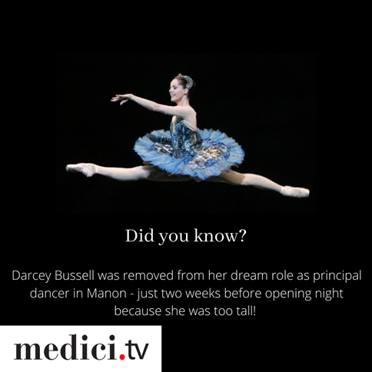
🎶 Everyday I’m Busslin’🎶

...Why not relax after a hard day’s work and watch the brilliant Darcey Bussell documentary on Medici.tv free at your library

